Project Title: CAR RESALE VALUE PREDICTION

Project Design Phase-I - Solution Fit Template Team ID: PNT2022TMID10364

|  |  |  |  |  |  |  |  |  |  |  |
| --- | --- | --- | --- | --- | --- | --- | --- | --- | --- | --- |
|  |  | |  |  | |  |  | | |  |
| 3. TRIGGERS | TR | 10. YOUR SOLUTION | SL | 8. CHANNELS of BEHAVIOUR | CH |  |
| When it comes to motor vehicles, all the time | |  |  | |  | 8.1 ONLINE | | |
| This system is built by Machine learning and regression model. By using this model we can predict the resale value of the car at any time anywhere. | |  |
| When researching, customers don’t look for information on auto brand websites alone, they visit comparison sites to check prices and user reviews. | | |
| people are posting pictures of the car as they d their Sunday drive or even just because it has h a wash. We have all seen the slamming cars ge online when they break down! We trust these people to lead us to the right vehicle and to giv us advice to help our buying decisions. | | o ad t  e |

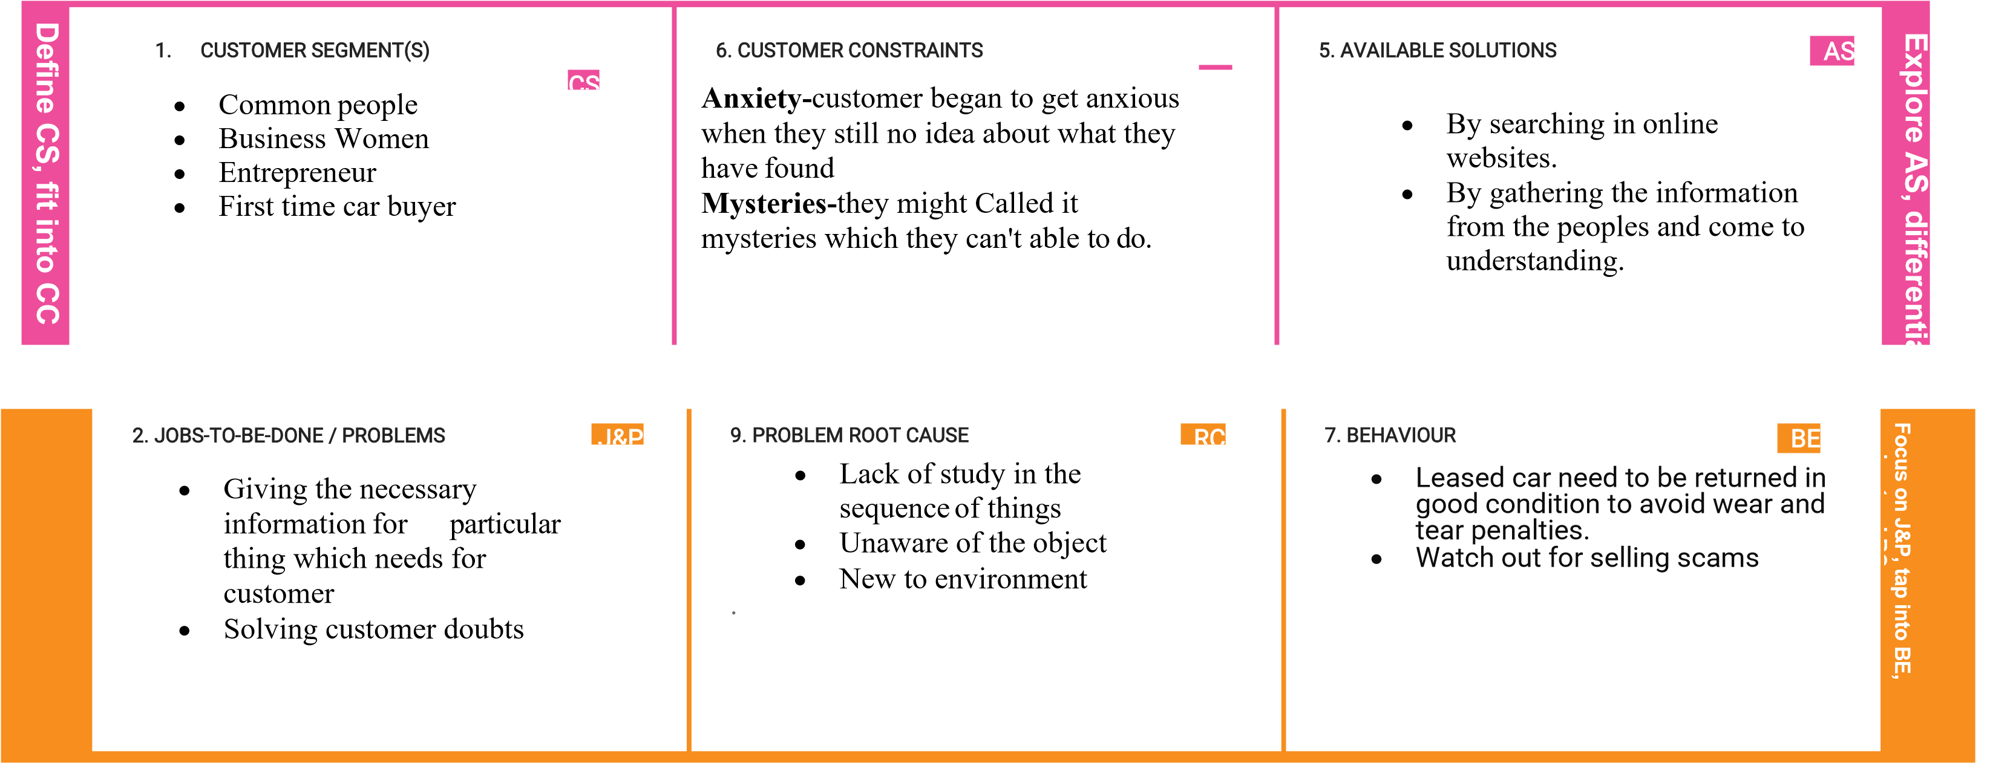

|  |  |  |  |  |  |  |
| --- | --- | --- | --- | --- | --- | --- |
|  |  | | |  | 8.2 OFFLINE    When customer wanted to buy a car they would visit one auto dealership after another, talking with salespeople and seeing where they could get the best price. |  |
| 4. EMOTIONS: BEFORE / AFTER | EM |  |
| Before buying a car they experience a state of | | |
| elation, joy , delight etc.,      After buying a car the sense of achievement they feel when they drive it home is linked to the fact that you are now the owner of the car. | | |



I

d

e

n

ti

f